My Home Learning File



Name………………………

Class………………….

Please make sure this file comes to school daily.

**Y1 Home Learning Expectations**

We ask our parents and carers to help, support and encourage their child to complete the home learning tasks that are set.

Our expectation for home learning in Year Y1 is as follows:

* Daily reading (and discussion about the book) to or with an adult at home, with the reading diary completed and signed each day.
* Practise 5 spellings a week on Spelling Shed along with daily practise of the sound learnt in class that day.
* Complete one maths activity on Quiz Shed per week, as set by the class teacher and practise times tables once a week.
* One subject curriculum home learning task per half term.

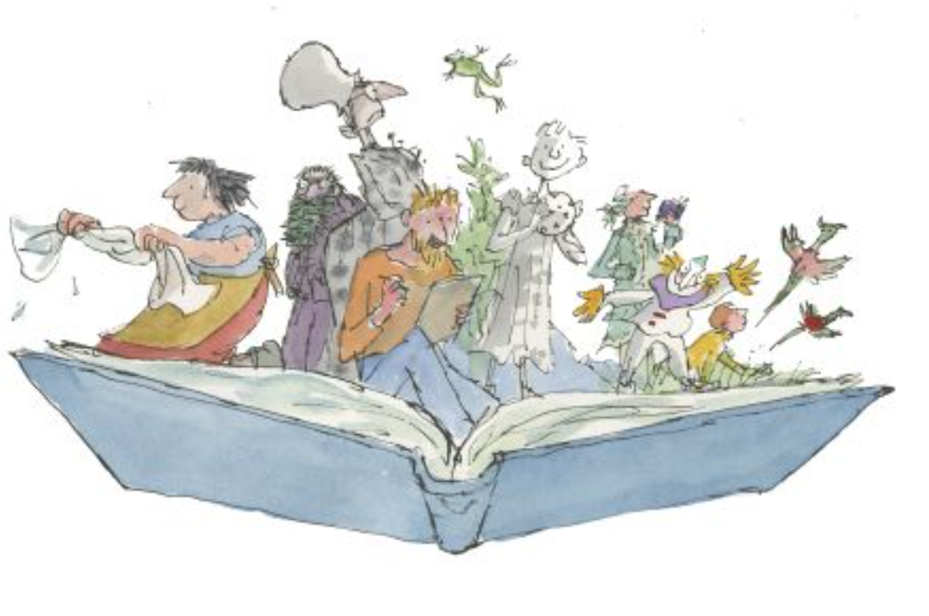

**Phonics**

In Year 1, Children practise their phonics daily. They learn to read and write the different sounds and blend them together. This helps and supports them with both their reading and writing. It is important that the children continue to consolidate their learning and practise their sounds.

The children will wear a sticker home with the sound that they have been learning that day, please ask them about this and practise saying it, children can also look out for it in their reading books.

|  |  |  |
| --- | --- | --- |
| Phase | Set | Focus sounds |
| Phase 2 | 1/2 | s a t p i n m d | Year Reception |
| 3 | g o c k |
| 4 | ck e u r |
| 5 | h b f ff l ll ss |
| Phase 3 | 6 | j v w x |
| 7 | y z zz qu |
| 8 | ch sh th ng |
| 9 | ai ee igh oa oo |
| 10 | ar or ur ow oi |
| 11 | ear air ure er |
| Phase 4 | 12 | Consolidation |
| Phase 5 | 13 | zh wh ph | Year 1 |
| 14 | ay a-e eigh ey ei |
| 15 | ea e-e ie ey y |
| 16 | Ie i-e y i |
| 17 | ow o-e o oe |
| 18 | ew ue u-e u oul |
| 19 | aw au al |
| 20 | ire r ear |
| 21 | ou oy |
| 22 | eer ere are ear |
| 23 | c k ck ch |
| 24 | ce ci cy sc stl se |
| 25 | ge gig y dge |
| 26 | le mb kn gn wr |
| 27 | tch tion sssion cial ea wa o |

**Reading**



Learning to read is probably the most important part of your child’s learning at primary school. Reading helps children to understand things, it enables them to express their feelings and it fires their imagination.

Your child will make accelerated progress with their reading if you **find the time to read with them every day** (for about 10 minutes).

Find a comfortable place to read with your child. Encourage them to read the text but do not put too much pressure on them; you can always read to them or try again at another time).

They will also benefit from seeing you read. When you read you are showing them that reading matters and that it is something that brings *you* a lot of pleasure.

We ask all children to read daily at home. Please make sure you sign the diary once you have read with your child. If you have any comments, please also add them.

**Questions to ask your child when reading**

# You can help your child to understand what they’re reading (reading comprehension) by asking them questions about what they’ve read and about what might happen next in the text. Here are some examples of the types of questions you might want to ask them during or after they’ve read with you:

* *Do you like this character? Why / why not?*
* *Which words best describe that character?*
* *How do you think that character felt when…?*
* 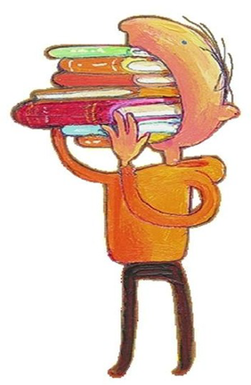*How did the story make you feel? Why?*
* *Where is this book set? How do you know?*
* *When do you think this story happened? Why do you think that?*
* *What do you think might happen next?*
* *Would you recommend this book to a friend? Why / why not?*

**What have you read over the school holidays?**

|  |
| --- |
|  |

**Spellings**

Children will have weekly spelling tests, these will be on a Friday. They will be given 5 spellings and tested a week later. They will then practise the spellings again the following week and apply them to sentences, they will be re-tested on any they got wrong the previous week and the application of the words.

Each year group has a set of key words to learn to spell, these words will also be covered through the weekly spellings.

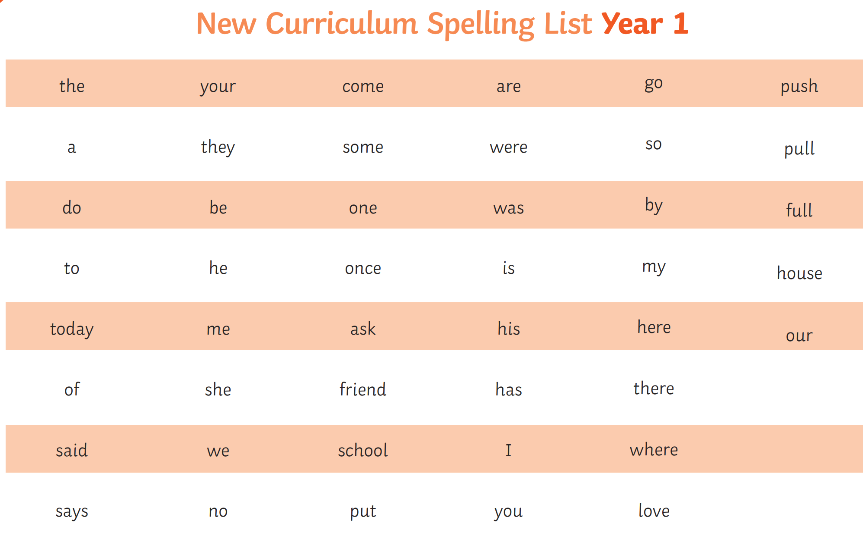

|  |  |  |  |
| --- | --- | --- | --- |
| **Understanding prefixes and suffixes** | | | |
| -s (cats) | -ing (jumping) | -ed (buzzed, needed, jumped) | un- (unlock) |
| -es (catches) | -er (hunter) | -est (quickest) |  |

**Maths**

Each week we ask the children to complete one activity on Quiz Shed, if you would prefer the paper copy that is fine too. These will be handed out or uploaded on a Friday and collected back in on a Thursday.

Times tables help to support the children build their maths knowledge and enable them to problem solve confidently and accurately.

In year 1 we teach the children to be able to recall the 2 times table, to be able to recall the 10 times table and to be able to count in steps of 5. Please practice these with your children at home.

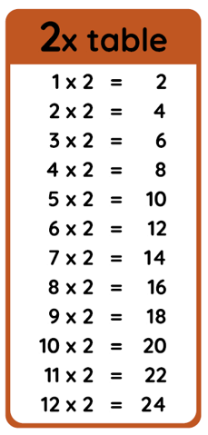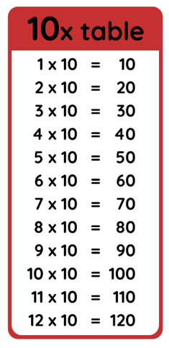

I’m learning to count in multiples of 5:

**5, 10, 15, 20, 25, 30, 35, 40, 45, 50, 55, 60**

**End of Year 1 National Reading Expectations**

|  |
| --- |
| **Reading** |
| **Word reading** |
| 1. I can apply phonic knowledge and skills as the route to decode words. |
| 2. I can respond speedily with the correct sound to graphemes for all 40+ phonemes*,* including, where applicable, alternative sounds for graphemes. |
| 3. I can read accurately by blending sounds in unfamiliar words containing clusters of letters that make a sound (graphical phoneme) that have been taught. |
| 4. I can read common exception words, noting unusual correspondences between spelling and sound and where these occur in the word. |
| 5. I can read words containing taught clusters of letters that make a sound (graphical phoneme) and –s, -es, -ing, -ed, -er and -est endings. |
| 6. I can read other words of more than one syllable that contain taught clusters of letters that make a sound (graphical phoneme). |
| 7. I can read words with contractions (e.g., I’m, I’ll, we’ll) and understand that the apostrophe represents the omitted letter(s). |
| 8. I can read aloud accurately books that are consistent with their phonic knowledge and that do not require them to use other strategies to work out words. |
| 9. I can re-read these books to build up their fluency and confidence in word reading. |
| **Comprehension** |
| *Develop pleasure in reading, motivation to read, vocabulary and understanding by:* |
| 10. I can listen to and discuss a wide range of poems, stories and non-fiction at a level beyond that at which I can read independently. |
| 11. I can be encouraged to link what I read or hear read to my own personal experiences. |
| 12. I am becoming very familiar with key stories, fairy stories and traditional tales, retelling them and considering their particular characteristics. |
| 13. I can recognise and join in with predictable phrases. |
| 14. I am learning to appreciate rhymes and poems, and able to recite some by heart. |
| 15. I can discuss word meanings, linking new meanings to those already known. |
| *Understand both the books I can already read accurately and fluently and those I listen to by:* |
| 16. I can draw on what I already know or on background information and vocabulary provided by the teacher. |
| 17. I can check that the text makes sense to me as I read and correct inaccurate reading. |
| 18. I can discuss the significance of the title and events. |
| 19. I can make inferences on the basis of what is being said and done. |
| 20. I can predict what might happen on the basis of what has been said so far. |
| 21. I can participate in discussion about what is read to me, taking turns and listening to what others say. |
| 22. I can explain clearly my understanding of what is read to me. |

**End of Year 1 National Writing Expectations**

|  |
| --- |
| **Writing** |
| **Transcription: Spelling** |
| 1. I can spell words containing each of the 40+ phonemes already taught. |
| 2. I can spell common exception words. |
| 3. I can spell the days of the week. |
| 4. I can name the letters of the alphabet in order and use letter names to distinguish between alternative spellings of the same sound. |
| 5. I can use the spelling rule for adding -s or -es as the plural marker for nouns and the third person singular marker for verbs. |
| 6. I can use the prefix un-. |
| 7. I can use the suffixes -ing, -ed, -er and -est where no change is needed in the spelling of root words. |
| 8. I can apply simple spelling rules and guidance from Stage 1. |
| 9. I can write from memory simple dictated sentences including the words taught so far. |
| **Transcription: Handwriting** |
| 10. I can sit correctly at a table, hold a pencil comfortably and correctly. |
| 11. I can begin to form lower-case letters in the correct direction, starting and finishing in the right place. |
| 12. I can form capital letters and digits 0 – 9. |
| 13. I can understand which letters belong to which handwriting ‘families’ (i.e. letters that are formed in similar ways). |
| **Writing: Composition** |
| 14. I can write sentences: saying out loud what I am about to write and composing a sentence orally before writing it. |
| 15. I can write sentences: sequencing sentences to form short narratives. |
| 16. I can write sentences: re-reading what I have written to check that it makes sense. |
| 17. I can discuss what I have written with the teacher or other pupils. |
| 18. I can read aloud my writing clearly enough to be heard by my peers and the teacher. |
| **Writing: Vocabulary, Grammar and Punctuation** |
| 19. I can leave spaces between words. |
| 20. I can join words and clauses using *and.* |
| 21. I can begin to punctuate sentences using a capital letter, full stop, question or exclamation mark. |
| 22. I can use capital letters for names of people, places, days of the week, personal pronoun ‘I’. |
| 23. I can learn how to use Y1 Grammar. |
| 24. I can use the grammatical terminology for Stage 1 in discussing my writing. |

**End of Year 1 National Maths Expectations**

|  |
| --- |
| **Maths** |
| **Place value** |
| 1. I can count to and across 100, forwards and backwards, beginning with 0 or 1, or from any given number. Count, read and write numbers to 100 in numerals. |
| 2. I can count in multiples of twos, fives and tens. |
| 3. Given a number, I can identify one more and one less. |
| 4. I can identify and represent numbers using objects and pictorial representations including the number line, and use the language of: equal to, more than, less than (fewer), most, least. |
| 5. I can read and write numbers from 1 to 20 in numerals and words. |
| **Add and subtract** |
| 6. I can read, write and interpret mathematical statements involving addition (+), subtraction (-) and equals (=) signs. |
| 7. I can represent and use number bonds and related subtraction facts within 20. |
| 8. I can add and subtract one-digit and two-digit numbers to 20, including zero. |
| 9. I can solve one-step problems that involve addition and subtraction, using concrete objects and pictorial representations, and missing number problems such as 7 = - 9. |
| **Multiplication and division** |
| 10. I can solve one-step problems involving multiplication and division, by calculating the answer using concrete objects, pictorial representations and arrays with teacher support. |
| **Fractions** |
| 11. I can recognise, find and name a half as one of two equal parts of an object, shape or quantity. |
| 12. I can recognise, find and name a quarter as one of four equal parts of an object, shape or quantity. |
| **Measure** |
| 13. I can compare, describe & solve practical problems for: lengths/heights (long/short/tall, half/double); mass/weight (heavier/lighter); capacity/volume (full/empty, more/less); time (quicker/slower/later). |
| 14. I can measure and begin to record the following: lengths/heights; mass/weight; capacity/volume; time (hours, minutes, seconds). |
| 15. I can recognise and know the value of different denominations of coins and notes. |
| 16. I can sequence events in chronological order using language such as: before and after, next, first, today, yesterday, tomorrow, morning, afternoon and evening. |
| 17. I can recognise and use language relating to dates, including days of the week, weeks, months and years. |
| 18. I can tell the time to the hour and half past the hour and draw the hands on a clock face to show these times. |
| **Geometry** |
| 19. I can recognise and name common 2-D shapes (e.g. rectangles, circles and triangles) and 3-D shapes (e.g. cuboids (including cubes), pyramids and spheres). |
| 20. I can describe position, directions and movements, including half, quarter and three-quarter turns. |

**Curriculum Based Learning**

Each Half Term we ask the children to complete one piece of home learning based around their big question, this will be added to the file.



