My Home Learning File



Name………………………

Class………………….

Please make sure this file comes to school daily.

**Y2 Home Learning Expectations**

We ask our parents and carers to help, support and encourage their child to complete the home learning tasks that are set.

Our expectation for home learning in Year 2 is as follows:

* Daily reading (and discussion about the book) to or with an adult at home, with the reading diary completed and signed each day.
* Complete one activity on Quiz Shed per week, as set by the class teacher.
* Children will begin with practising phonics each night, these will be sent home by the class teacher. Once phase 5 is complete, children will move onto reading, recognising and practising 15 spellings from the word list sent home and on Spelling Shed. Children will be tested the following week and re-tested on any they got wrong the previous week and the application of the words.
* Complete at least one session per week on Times Tables Rock Stars.
* One subject curriculum home learning task per half term.

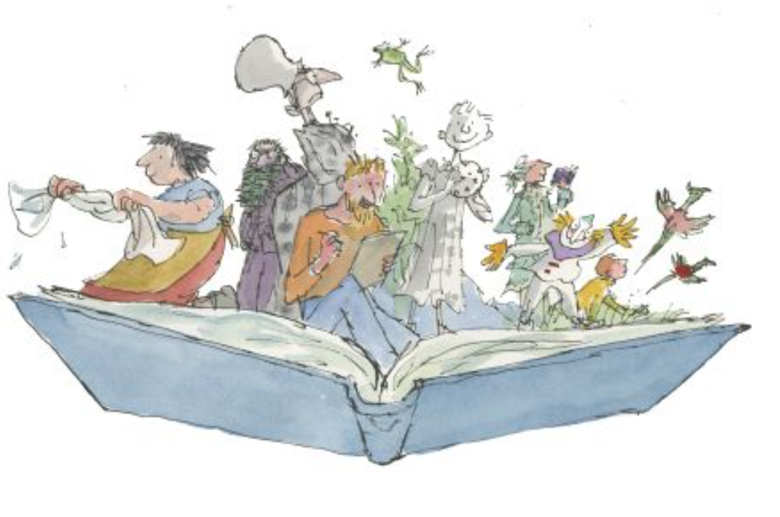

**Phonics**

Children may spend some time consolidating their phonic knowledge in Year 2. This helps and supports them with both their reading and writing. It is important that the children continue to consolidate their learning and practise their sounds.

|  |  |  |
| --- | --- | --- |
| Phase | Set | Focus sounds |
| Phase 2 | 1/2 | s a t p i n m d | Year Reception |
| 3 | g o c k |
| 4 | ck e u r |
| 5 | h b f ff l ll ss |
| Phase 3 | 6 | j v w x |
| 7 | y z zz qu |
| 8 | ch sh th ng |
| 9 | ai ee igh oa oo |
| 10 | ar or ur ow oi |
| 11 | ear air ure er |
| Phase 4 | 12 | consolidation |
| Phase 5 | 13 | zh wh ph | Year 1 |
| 14 | ay a-e eigh ey ei |
| 15 | ea e-e ie ey y |
| 16 | Ie i-e y i |
| 17 | ow o-e o oe |
| 18 | ew ue u-e u oul |
| 19 | aw au al |
| 20 | ire r ear |
| 21 | ou oy |
| 22 | eer ere are ear |
| 23 | c k ck ch |
| 24 | ce ci cy sc stl se |
| 25 | ge gig y dge |
| 26 | le mb kn gn wr |
| 27 | tch tion sssion cial ea wa o |

**Reading**



Learning to read is probably the most important part of your child’s learning at primary school. Reading helps children to understand things, it enables them to express their feelings and it fires their imagination.

Your child will make accelerated progress with their reading if you **find the time to read with them every day** (for about 10 minutes).

Find a comfortable place to read with your child. Encourage them to read the text but do not put too much pressure on them; you can always read to them or try again at another time.

They will also benefit from seeing you read. When you read you are showing them that reading matters and that it is something that brings *you* a lot of pleasure.

We ask all children to read daily at home. Please make sure you sign the diary once you have read with your child. If you have any comments, please also add them.

**Questions to ask your child when reading**

# You can help your child to understand what they’re reading (reading comprehension) by asking them questions about what they’ve read and about what might happen next in the text. Here are some examples of the types of questions you might want to ask them during or after they’ve read with you:

* *Do you like this character? Why / why not?*
* *Which words best describe that character?*
* *How do you think that character felt when…?*
* 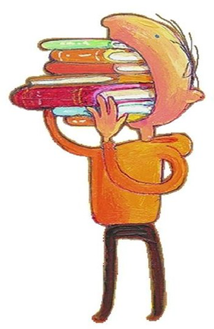*How did the story make you feel? Why?*
* *Where is this book set? How do you know?*
* *When do you think this story happened? Why do you think that?*
* *What do you think might happen next?*
* *Would you recommend this book to a friend? Why / why not?*

**What have you read over the school holidays?**

|  |
| --- |
|  |

**Spellings**

Children will have weekly spelling tests, these will be on a Friday. They will be given 15 spellings and tested a week later, they will then practise the spellings again the following week and apply them to sentences, they will be re-tested on any they got wrong the previous week and the application of the words.

Each year group has a set of key words to learn to spell, these words will also be covered through the weekly spellings.

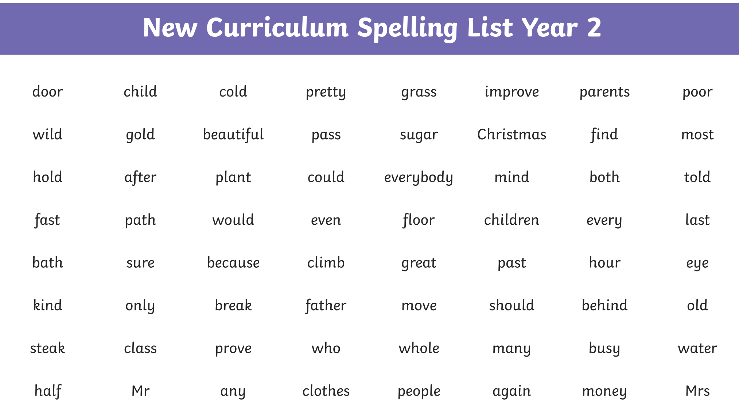

|  |  |  |  |  |  |
| --- | --- | --- | --- | --- | --- |
| **Understanding prefixes and suffixes** | | | | | |
| Change -y to -i before -ment  (merriment) |  | Double consonant before -ing (pat =  patting) |  | Drop -e before -est (nice = nicest) |  |
| Change -y to -i before -less  (penniless) |  | Double consonant before -ed (hum =  hummed) |  | Drop -e before -y (shine = shiny) |  |
| Change -y to -i before -ly (happily) |  | Double consonant before -er (sad =  sadder) |  | Drop -e before -er (hike = hiker) |  |
| Change -y to -i before -ful (plentiful) |  | Double consonant before -est (fat =  fattest) |  | Drop -e before -ing (hike = hiking) |  |
| Change -y to -i before -ness  (happiness) |  | Double consonant before -y (run =  runny) |  | Drop -e before -ed (hike = hiked) |  |
| -es after y (try = tries) |  | -ness (sadness) |  | -less (hopeless) |  |
| -ed after y (reply = replied) |  | -ful (careful) |  | - ly (badly) |  |
| -er after y (copy =copier) |  | -ment (enjoyment) |  | -est after y (happy = happiest) |  |

|  |  |  |  |  |  |  |  |  |  |  |  |
| --- | --- | --- | --- | --- | --- | --- | --- | --- | --- | --- | --- |
| **Spell and read sounds** | | | | | | | | | | | |
| ge (charge) |  | kn (knock) |  | el (tunnel) |  | s (treasure) |  | a (want) |  | al (walk) |  |
| dge (badge) |  | gn (gnat) |  | al (metal) |  | tion (station) |  | a (squash) |  | all (ball) |  |
| g (giant) |  | wr (wrap) |  | il (pencil) |  | o (mother) |  | or (word) |  |  |  |
| c (race) |  | le (apple) |  | y (cry) |  | ey (donkey) |  | ar (warm) |  |  |  |

**Maths**

Each week we ask the children to complete one activity on Quiz Shed, if you would prefer the paper copy that is fine too. These will be handed out or uploaded on a Friday and collected back in on the following Thursday.

Times tables help to support the children build their maths knowledge and enable them to problem solve confidently. The children will also have times tables set on Times Tables Rock Stars for them to practise at least once a week. They will also have weekly times tables tests to reinforce this.

In year 2 we teach the children to be able to recall the 2 times table, to be able to recall the 5 times table, to be able to recall the 10 times table and to be able to count in steps of 3. Please practise these with your children at home.

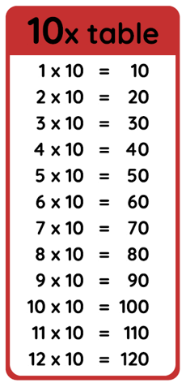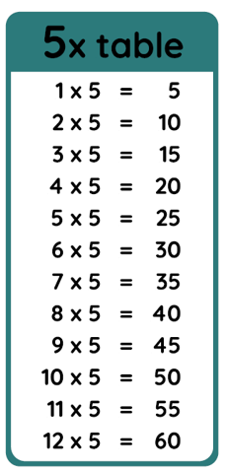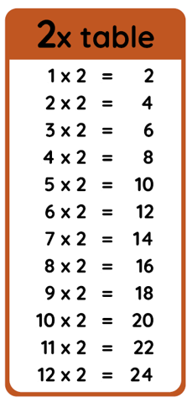

I’m learning to count in multiples of 3:

**3, 6, 9, 12, 15, 18, 21, 24, 27, 30, 33, 36**

**End of Year 2 National Reading Expectations**

|  |
| --- |
| **Reading** |
| **Word Reading** |
| 1. I can continue to apply phonic knowledge and skills to decode words until automatic decoding has become embedded and reading is fluent. |
| 2. I can read accurately by blending the sounds in words that contain the graphemes taught so far, especially recognising alternative sounds for graphemes. |
| 3. I can read accurately words of two or more syllables that contain the same graphemes as above. |
| 4. I can read words containing common suffixes. |
| 5. I can read further common exception words, noting unusual correspondences between spelling and sound where these occur in the word. |
| 6. I can read most words quickly and accurately, without overt sounding and blending, when they have been frequently encountered. |
| 7. I can read aloud books closely matched to my improving phonic knowledge, sounding out unfamiliar words accurately, automatically and without undue hesitation. |
| 8. I can re-read these books to build up my fluency and confidence in word reading. |
| **Comprehension** |
| Develop pleasure in reading, motivation to read, vocabulary and understanding by: |
| 9. I can listen to, discuss and express views about a wide range of contemporary and classic poetry, stories and non-fiction at a level beyond that at which I can read independently. |
| 10. I can discuss the sequence of events in books and how items of information are related. |
| 11. I am becoming increasingly familiar with and retelling a wider range of stories, fairy stories and traditional tales. |
| 12. I am being introduced to non-fiction books that are structured in different ways. |
| 13. I can recognise simple recurring literary language in stories and poetry. |
| 14. I can discuss and clarify the meanings of words, linking new meanings to known vocabulary; discussing my favourite words and phrases. |
| 15. I am continuing to build up a repertoire of poems learnt by heart, appreciating these and reciting some, with appropriate intonation to make the meaning clear. |
| Understand both the books they can already read accurately and fluently and those they listen to by: |
| 16. Drawing on what I already know or on background information and vocabulary provided by the teacher. |
| 17. Checking that the text makes sense to me as I read and correcting inaccurate reading. |
| 18. Making inferences on the basis of what is being said and done. |
| 19. Answering and asking questions. |
| 20. Predicting what might happen on the basis of what has been read so far. |
| 21. Participating in discussion about books, poems and other works that are read to me and those that I can read for myself, taking turns and listening to what others say. |
| 22. Explaining and discussing my understanding of books, poems and other material, both those that I listen to and those that I read for myself. |

**End of Year 2 National Writing Expectations**

|  |
| --- |
| **Writing** |
| **Transcription: spelling** |
| 1.I can spell by segmenting spoken words into phonemes and representing these by graphemes, spelling many correctly. |
| 2. I can learn new ways of spelling phonemes for which one or more spellings are already known, learn some words with each spelling including a few common homophones. |
| 3. I can spell common exception words. |
| 4. I can spell more words with contracted forms and the possessive apostrophe (singular). |
| 5. I can distinguish between homophones and near homophones. |
| 6. I can add suffixes to spell longer words e.g. –ment, *–*ness, *–*ful, *–*less*, –*ly. |
| 7. I can apply spelling rules and guidelines for Stage 2. |
| 8. I can write from memory simple dictated sentences including the words and punctuation taught so far. |
| **Transcription: handwriting** |
| 9. I can form lower-case letters to the correct size relative to one another. |
| 10. I can start using some of the diagonal and horizontal strokes needed to join letters and understand which letters, when adjacent to one another, are best left unjoined. |
| 11. I can write capital letters and digits of the correct size, orientation and relationship to one another and to lower case letters. |
| 12. I can use spacing between words that reflects the size of the letters. |
| **Writing: composition** |
| 13. I can develop positive attitudes towards and stamina for writing by: *writing narratives about personal experiences (real and fiction); real events; poetry and writing for different purposes.* |
| 14. I can consider what I am going to write by: *planning/saying what I am going to write about; writing down ideas/key words/new vocab; encapsulating ideas sentence by sentence.* |
| 15. I can make simple additions, revisions and corrections to my writing by: *evaluating writing with others; re-reading to check that it makes sense; proof-reading, spelling, grammar, punctuation.* |
| 16. I can read aloud what I have written with appropriate intonation to make the meaning clear. |
| **Writing: vocabulary, grammar and punctuation** |
| 17. I have learned how to use correctly: full stops, capital letters, exclamation/question marks, commas for lists, apostrophe for contracted forms/possessive (singular). |
| 18. I have learned how to use sentences with different forms: statement, question, exclamation, command. |
| 19. I have learned how to use expanded noun phrases to describe and specify. |
| 20. I have learned how to use the present and past tenses correctly and consistently including in the progressive form. |
| 21. I have learned how to use subordination using *when, if, that, because* and co-ordination using *or, and, but.* |
| 22. I have learned how to use Y2 Grammar: using suffixes to form nouns *(-ness, -er);* adjectives *(-ful, -less)* and adverbs *(-ly).* |
| 23. I have learned how to use some features of written Standard English. |
| 24. I can use and understand the grammatical terminology for Stage 2. |

**End of Year 2 National Maths Expectations**

|  |
| --- |
| **Maths** |
| **Place value** |
| 1. I can count in steps of 2, 3, and 5 from 0, and in tens from any number, forwards and backwards. |
| 2. I can recognise the place value of each digit in a two-digit number (tens, ones). |
| 3. I can identify, represent and estimate numbers using different representations, including the number line. |
| 4. I can compare and order numbers from 0 up to 100; use <, > and = signs. |
| 5. I can read and write numbers to at least 100 in numerals and in words. |
| **Addition and subtraction** |
| 6. I can solve problems with addition and subtraction: using concrete objects and pictorial representations; applying their increasing knowledge of mental and written methods. |
| 7. I can recall and use add and subtract facts to 20 fluently, derive and use related facts up to 100. |
| 8. I can add and subtract numbers using concrete objects, pictorial representations, and mentally, including: a 2-digit no and 1s or 10s; two 2-digit numbers; adding three 1-digit numbers. |
| 9. I can show that addition of two numbers can be done in any order (commutative) and subtraction of one number from another cannot. |
| 10. I can recognise and use the inverse relationship between addition and subtraction and use this to check calculations and missing number problems. |
| **Multiplication and division** |
| 11. I can recall and use multiplication and division facts for the 2, 5 and 10 multiplication tables, including recognising odd and even numbers. |
| 12. I can calculate mathematical statements for multiplication and division within the multiplication tables and write them using the multiplication (×), division (÷) and equals (=) signs. |
| 13. I can show that multiplication of two numbers can be done in any order (commutative) and division of one number by another cannot. |
| 14. I can solve problems involving multiplication and division, using materials, arrays, repeated addition, mental methods, and multiplication and division facts, including problems in contexts. |
| **Fractions** |
| 15. I can recognise/find/name/write fractions ⅟₃, ⅟₄, 2/4, ᶟ∕₄ of a length, shape, set of objects, quantity. |
| 16. I can write simple fractions e.g. ⅟₂ of 6 = 3 and recognise the equivalence of 2/4 and ⅟₂. |
| **Measurement** |
| 17. I can choose/use appropriate stand units to estimate/measure length/height (m/cm); mass (kg/g); temp (°C); cap (litres/ml) to nearest unit, using rulers, scales, thermometers and measuring vessels. |
| 18. I can compare and order lengths, mass, volume/capacity and record the results using >, < and =. |
| 19. I can recognise and use symbols for pounds (£) and pence (p); combine amounts to make a particular value and find different combinations of coins that equal the same amounts of money. |
| 20. I can solve simple problems in a practical context involving addition and subtraction of money of the same unit, including giving change. |
| 21. I can compare and sequence intervals of time. |
| 22. I can tell and write the time to five minutes, including quarter past/to the hour and draw the hands on a clock face to show these times. |
| **Geometry** |
| 23. I can identify and describe the properties of 2D shapes, including the number of sides and symmetry in a vertical line. |
| 24. I can identify and describe the properties of 3D shapes, including the no. of edges, vertices and faces. |
| 25. I can identify 2D shapes on the surface of 3D shapes, e.g. circle on a cylinder; a triangle on a pyramid. |
| 26. I can compare and sort common 2D and 3D shapes and everyday objects. |
| 27. I can order and arrange combinations of mathematical objects in patterns. |
| 28. I can use math vocab to describe position, direction & movement including rotation as a turn & in terms of right angles for ⅟₄, ⅟₂, & ᶟ∕₄ turns (clock/anti-clockwise), and movement in a straight line. |
| **Statistics** |
| 29. I can interpret and construct simple pictograms, tally charts, block diagrams and simple tables. |
| 30. I can ask and answer simple questions by counting the number of objects in each category and sorting the categories by quantity; ask and answer questions about totalling and comparing categorical data. |

**Curriculum Based Learning**

Each Half term we ask the children to complete one piece of home learning based around their big question, this will be put added to the file.



