Term | Summer 1 |  | Summer 2
No. of weeks | 5 Weeks |  | 6 Weeks 3 days
Gateway | Flourishing |  | Exploration
Church Value | Responsibility |  | Passion
Metacognition | Creativity |  | Collaboration
Start / End Date | 25-04-22 to 12– 05-22  (3 weeks) | 16-05-22 to 27-05-22  (2 weeks) | 13-06-22 to  01-07-22  (3 weeks) | 04-07-22 to  26-07-22  (3week)
Key Question | How do people flourish in a region dealing with natural disasters? | Forces and magnets  Can I present my findings of an investigation to an audience? | Local history study
Main Subject | Geography | Science | History | Art
Other Subject | English | English | English
Concept  Development | Place  People | Investigation  Energy (introduced in KS2) | Chronology  Power and conflict | Colour
Class Reading | The Explorer  Jacqueline Wilson |  | The Wild Way Home  Sophie Kirtley
Writing | Report writing, organisation, paragraphs, checking for sense, tenses | Non-chronological report  Editing, vocabulary, presenting findings, sentence structure | Can a battery defend a community | Can I design a print that represents my school
Outcome | Children will write a newspaper report about a hurricane. | Children to be scientists giving presentation to families | Narrative | Collaboratively produce large prints representing our school to be displayed in the playground.
Character Development | To support themselves and others with their wellbeing. | To take responsibility for ourselves and others | How can I be the best version of myself? | How can I show passion?
Ongoing subjects | R.E  P.E  Music | R.E  P.E  Modern Foreign Languages (French) | R.E  P.E  Music | R.E  P.E  Modern Foreign Languages (French)
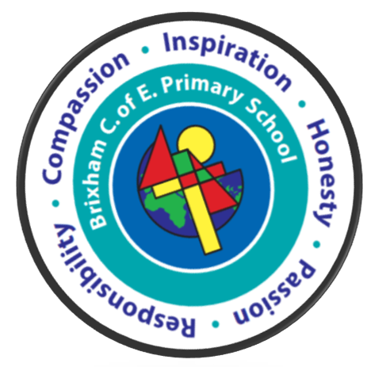 Summer Term Overview 21/22 – Year 4

