My Home Learning File



Name………………………

Class………………….

Please make sure this file comes to school daily.

**Reception Class**

**Home Learning Expectations**

We ask our parents and carers to help, support and encourage their child to complete the home learning tasks that are set.

Our expectation for home learning in Reception is as follows:

* Daily reading (and discussion about the book) to or with an adult at home, with the reading diary completed and signed each day.
* Spotting sounds and ‘tricky words’ when looking at texts.
* One subject curriculum home learning task per half term.

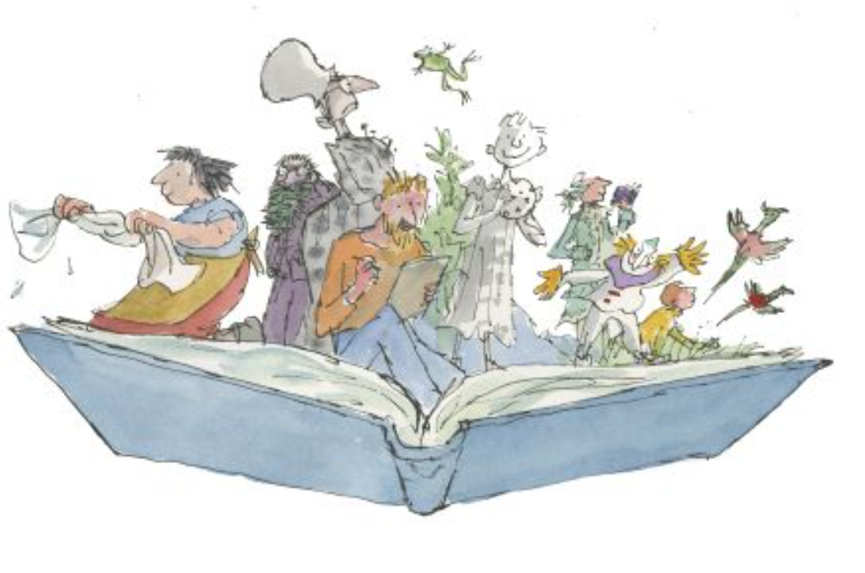

**Phonics**

In Reception, Children practise their phonics daily. They learn to read and write the different sounds and blend them together. This helps and supports them with both their reading and writing. It is important that the children continue to consolidate their learning and practise their sounds.

The children will wear a sticker home with the sound that they have been learning that day, please ask them about this and practise saying it, children can also look out for it in their reading books.

|  |  |  |
| --- | --- | --- |
| Phase | Set | Focus sounds |
| Phase 2 | 1/2 | s a t p i n m d | Year Reception |
| 3 | g o c k |
| 4 | ck e u r |
| 5 | h b f ff l ll ss |
| Phase 3 | 6 | j v w x |
| 7 | y z zz qu |
| 8 | ch sh th ng |
| 9 | ai ee igh oa oo |
| 10 | ar or ur ow oi |
| 11 | ear air ure er |
| Phase 4 | 12 | consolidation |
| Phase 5 | 13 | zh wh ph | Year 1 |
| 14 | ay a-e eigh ey ei |
| 15 | ea e-e ie ey y |
| 16 | Ie i-e y i |
| 17 | ow o-e o oe |
| 18 | ew ue u-e u oul |
| 19 | aw au al |
| 20 | ire r ear |
| 21 | ou oy |
| 22 | eer ere are ear |
| 23 | c k ck ch |
| 24 | ce ci cy sc stl se |
| 25 | ge gig y dge |
| 26 | le mb kn gn wr |
| 27 | tch tion ssion cial ea wa o |

**Tricky Words**

We will be sending home ‘Tricky Words’ for the children to practise with you.

Tricky words are not phonetically regular and so need to be learnt by using the ‘whole word’ approach. The children will develop a sight vocabulary of these words.

|  |  |
| --- | --- |
|  |  |

**Reading**



Learning to read is probably the most important part of your child’s learning at primary school. Reading helps children to understand things, it enables them to express their feelings and it fires their imagination.

Your child will make accelerated progress with their reading if you **find the time to read with them every day** (for about 10 minutes).

Find a comfortable place to read with your child. Encourage them to read the text but do not put too much pressure on them; you can always read to them or try again at another time.

They will also benefit from seeing you read. When you read you are showing them that reading matters and that it is something that brings *you* a lot of pleasure.

We ask all children to read daily at home. Please make sure you sign the diary once you have read with your child. If you have any comments, please also add them.

**Questions to ask your child when reading**

# You can help your child to understand what they’re reading (reading comprehension) by asking them questions about what they’ve read and about what might happen next in the text. Here are some examples of the types of questions you might want to ask them during or after they’ve read with you:

* Do you like this character? Why / why not?
* Which words best describe that character?
* How do you think that character felt when…?
* 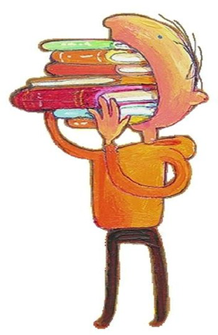How did the story make you feel? Why?
* Where is this book set? How do you know?
* When do you think this story happened? Why do you think that?
* What do you think might happen next?
* Would you recommend this book to a friend? Why / why not?

**Supporting Children with their Maths.**

Being able to recognise, count and accurately order numbers 0-20 (and beyond if your child is more capable) will be of huge benefit to your child. A secure knowledge of [numbers and counting](https://www.theschoolrun.com/maths/numbers-and-counting) will support them with mathematical problem-solving, not only in Reception but throughout school.

Numbers are all around us, so it is easy to incorporate number recognition and counting into daily life: try going on a number hunt, counting how many Lego bricks are in a tower and playing board games.

There are so many opportunities to work on number skills though play and daily life. Ask your child to tell you which number comes before 10 or after 16, and so on. Or why not make your own [number line](https://www.theschoolrun.com/what-number-line) to 20 on Post-Its or pieces of paper and ask your child to help write the numbers and add the correct number of pictures?

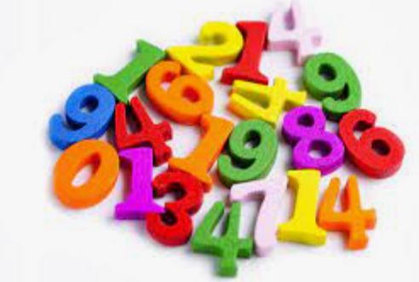

**End of Reception Expectations for Reading**

**Comprehension**

* Demonstrate understanding of what has been read to them by retelling stories and narratives using their own words and recently introduced vocabulary.
* Anticipate – where appropriate – key events in stories.
* Use and understand recently introduced vocabulary during discussions about stories, non-fiction, rhymes and poems and during roleplay.

**Word Reading**

* Say a sound for each letter in the alphabet and at least 10 digraphs.
* Read words consistent with their phonic knowledge by sound-blending.
* Read aloud simple sentences and books that are consistent with their phonic knowledge, including some common exception words.

**End of Reception Writing Expectations**

* Write recognisable letters, most of which are correctly formed.
* Spell words by identifying sounds in them and representing the sounds with a letter or letters.
* Write simple phrases and sentences that can be read by others.

**End of Reception Maths Expectations**

**Number**

* Have a deep understanding of numbers to 10, including the composition of each number.
* Subitise (recognise quantities without counting) up to 5.
* Automatically recall (without reference to rhymes, counting or other aids) number bonds up to 5 (including subtraction facts) and some number bonds to 10, including double facts.

**Numerical Patterns**

* Verbally count beyond 20, recognising the pattern of the counting system.
* Compare quantities up to 10 in different contexts, recognising when one quantity is greater than, less than or the same as the other quantity.
* Explore and represent patterns within numbers up to 10, including evens and odds, double facts and how quantities can be distributed equally.

**Curriculum Based Learning**

Each half term we ask the children to complete one piece of home learning based around their big question, this will be put added to the file.



