My Home Learning File



Name………………………

Class………………….

Please make sure this file comes to school daily.

**Y3 Home Learning Expectations**

We ask our parents and carers to help, support and encourage their child to complete the home learning tasks that are set.

Our expectation for home learning in Year 3 is as follows:

* Daily reading (and discussion about the book) to or with an adult at home.
* Reading diary completed by the child daily and signed by an adult at least once per week.
* Book review written after finishing each book.
* Complete one Maths activity on Maths Shed per week, as set by the class teacher.
* Complete at least two sessions per week on Times Tables Rock Stars.
* Learn the 15 spelling from the list sent home, children will be tested the following week, and retested the week after with either the spellings with errors or applying the words.

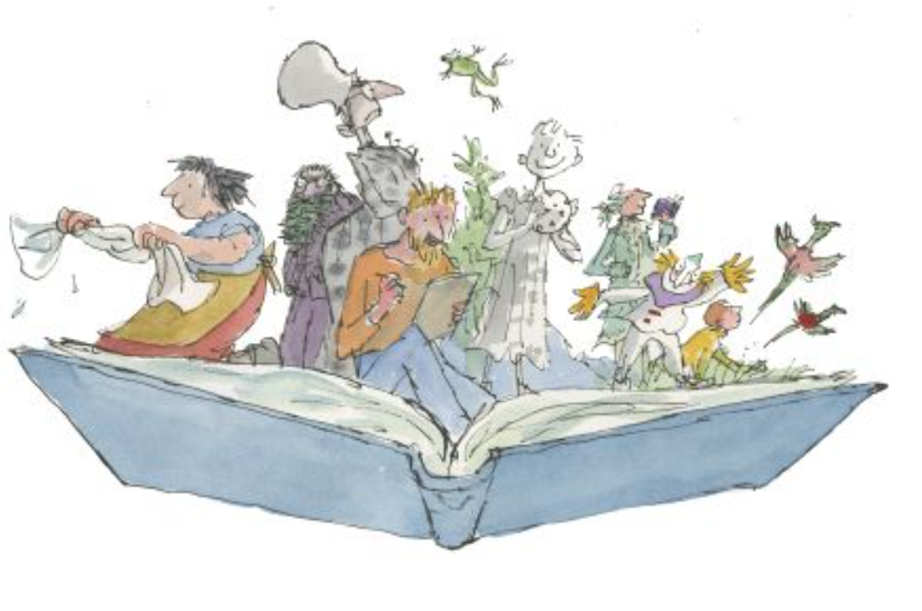

**Reading**



Learning to read is probably the most important part of your child’s learning at primary school. Reading helps children to understand things, it enables them to express their feelings and it fires their imagination.

Your child will make accelerated progress with their reading if you **find the time to read with them every day** (for about 10 minutes).

Find a comfortable place to read with your child. Encourage them to read the text but do not put too much pressure on them; you can always read to them or try again at another time (see the alternative ways to read with your child on the next page).

They will also benefit from seeing you read. When you read you are showing them that reading matters and that it is something that brings *you* a lot of pleasure.

We ask all children to read daily at home. Please make sure you sign the diary once you have read with your child. If you have any comments, please also add them.

**Questions to ask your child when reading**

# You can help your child to understand what they’re reading (reading comprehension) by asking them questions about what they’ve read and about what might happen next in the text. Here are some examples of the types of questions you might want to ask them during or after they’ve read with you:

* *Do you like this character? Why / why not?*
* *Which words best describe that character?*
* *How do you think that character felt when…?*
* 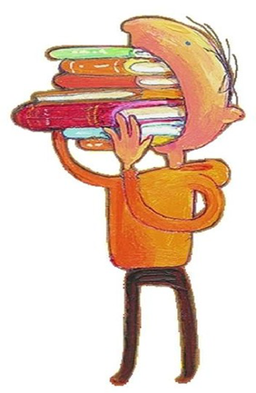*How did the story make you feel? Why?*
* *Where is this book set? How do you know?*
* *When do you think this story happened? Why do you think that?*
* *What do you think might happen next?*
* *Would you recommend this book to a friend? Why / why not?*

**What have you read over the school holidays?**

|  |
| --- |
|  |

**End of Year 3 National Reading Expectations**

|  |
| --- |
| **Reading** |
| **Word reading** |
| 1. I can develop a knowledge of root words, prefixes and suffixes (etymology and morphology) both to read aloud and to understand the meaning of new words I meet. |
| 2. I can read exception words, noting the unusual correspondences between spelling and sound, and where these occur in the word. |
| **Comprehension** |
| *Develop positive attitudes to reading and understanding of what I read by:* |
| 3. I can listen to and discuss a wide range of fiction, poetry, plays, non-fiction and reference or text books |
| 4. I can read books that are structured in different ways and read for a range of purposes with age appropriate content and interest level, with some support. |
| 5. I can use a dictionary to check the meaning of words that I have read. |
| 6. I have increased my familiarity with a wide range of books, including fairy stories, myths and legends, and retelling some of these orally |
| 7. I am beginning to identify themes and conventions in a wide range of books |
| 8. I can prepare simple poems and play scripts to read aloud and to perform, showing understanding through intonation, tone, volume and action |
| 9. I can discuss words and phrases that capture the reader’s interest and imagination |
| 10. I can recognise some different forms of poetry (e.g. free verse, narrative poetry). |
| *Understand what I have read, in books they can read independently by:* |
| 11. I am beginning to check that the text makes sense to me, discussing my understanding and explaining the meaning of words in context, with some support |
| 12. I can ask retrieval and some inference questions to improve my understanding of a text. |
| 13. I can draw basic inferences such as inferring characters’ feelings, thoughts and motives from their actions, and justifying inferences with some support. |
| 14. I am beginning to predict what might happen from details stated. |
| 15. I can identify main ideas drawn from more than one paragraph. |
| 16. I am beginning to identify how features of a text contribute to meaning. |
| 17. I can retrieve and record information from non-fiction texts. |
| 18. I can participate in discussions about both books that are read to me and those I can read myself. |

**Spellings**

Children will have weekly spelling tests and these will be on a Friday. They will be given fifteen spellings and tested a week later. They will then practice the spellings again the during the following week and apply them to sentences. They will be re-tested on any they got wrong the previous week and the application of the words.

Each year group has a set of key words to learn to spell, these words will also be covered through the weekly spellings.

|  |  |  |
| --- | --- | --- |
| **Spellings** | | |
|  |  |  |
| accident | famous | often |
| accidentally | February | quarter |
| answer | fruit | question |
| arrive | group | reign |
| build | heart | remember |
| certain | history | straight |
| circle | important | though |
| decide | island | although |
| describe | learn | thought |
| different | length | through |
| early | minute | weight |
| eight | naughty | woman |
| eighth | occasion | women |
|  | occasionally |  |

**End of Year 3 National Writing Expectations**

|  |
| --- |
| **Writing** |
| **Transcription: spelling** |
| 1. I can use prefixes and suffixes in writing. |
| 2. I can spell homophones. |
| 3. I can use the first two or three letters of a word to check its spelling in a dictionary with assistance. |
| 4. I can write from memory simple sentences that include words and punctuation taught so far. |
| **Transcription: handwriting** |
| 7. I can use the diagonal and horizontal strokes that are needed to join letters. |
| 8. I can increase the legibility, consistency and quality of my handwriting *(by ensuring that the downstrokes of letters are parallel and equidistant).* |
| **Writing: composition** |
| 9. I can plan writing by using other examples as a model for my own writing. |
| 10. I can draft & write by composing & rehearsing sentences orally. |
| 11.I can begin to organise my ideas into paragraphs. |
| 12. In narratives, I can create settings, characters and plot. |
| 13. In non-narrative material, I can use simple organisational devices such as headings and sub-headings with support. |
| 14. I can begin to evaluate and edit by assessing the effectiveness of my own and others’ writing. |
| 15. I can evaluate and edit vocabulary choices. |
| 16. I can proof-read for spelling and punctuation errors. |
| 17. I can begin to read aloud own writing to a group or whole class, using appropriate intonation and controlling tone and volume so that the meaning is clear. |
| **Writing: Vocabulary, Grammar and Punctuation** |
| 18. I can extend the range of sentences with more than one clause by using a wider range of conjunctions *e.g. when, if, because, although.* |
| 19. I can use the perfect form of verbs in contrast to the past tense. |
| 20. I can use conjunctions, adverbs and prepositions to express time and cause |
| 21. I can use Year 3 grammar: formation of nouns using a range of prefixes, use of a/an, word families. |
| 22. I can begin to identify main and subordinate clauses. |
| 23.I can indicate possession by using the possessive apostrophe with singular nouns and regular plurals. |
| 24. I can use inverted commas to punctuate direct speech. |
| 25. I can use and understand the grammatical terminology for Stage 3. |

**Maths**

Each week we ask the children to complete one activity on Math Shed, if you would prefer the paper copy that is fine too. These will be handed out or uploaded on a Friday and collected back in the following Thursday.

Times tables help to support the children build their maths knowledge and enable them to problem solve confidently and accurately.

In Key Stage 1, the children should have learnt, and be fluent in the 2, 5 and 10 times tables. In year 3, we ask the children to focus on the 3, 4 and 8 times tables. To extend the children’s learning, we would ask that they learn the related division facts and be able to recall both within a 6 second time frame.

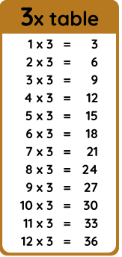 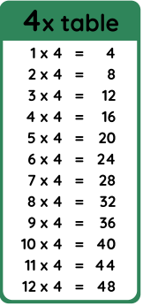 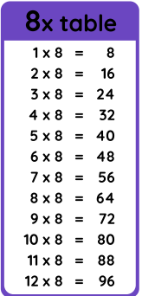

**End of Year 3 National Maths Expectations**

|  |
| --- |
| **Maths** |
| **Place value** |
| 1. I can count from 0 in multiples of 4, 8, 50 and 100. Find 10 or 100 more or less than a given number. |
| 2. I can recognise the place value of each digit in a three-digit number (hundreds, tens, ones). |
| 3. I can compare and order numbers up to 1000. Read and write numbers up to 1000 in numerals and in words. |
| 4. I can identify, represent and estimate numbers using different representations. |
| 5. I can solve number problems and practical problems involving these ideas. |
| **Addition and subtraction** |
| 6. I can add and subtract numbers mentally, including: a 3-digit no and 1s, 10s, 100s. |
| 7. I can add and subtract numbers with up to 3 digits, using formal written methods of columnar addition and subtraction. |
| 8. I can estimate the answer to a calculation and use inverse operations to check answers. |
| 9. I can solve problems, including missing number problems, using number facts, place value, and more complex addition/subtraction. |
| **Multiplication and division** |
| 10. I can recall and use multiplication and division facts for the 3, 4 and 8 multiplication tables. |
| 11. I can write and calculate math statements for x and ÷ using the tables I know, including 2-digit numbers times 1-digit numbers, using mental and formal written methods. |
| 12. I can solve problems and missing number problems, involving x and ÷, including integer scaling problems and correspondence problems in which n objects are connected to m objects. |
| **Fractions** |
| 13. I can count up and down in tenths; recognise that tenths arise from dividing an object into 10 equal parts and in dividing one-digit numbers or quantities by 10. |
| 14. I can recognise, find and write fractions of a discrete set of objects: unit fractions and non-unit fractions with small denominators. |
| 15. I can recognise and use fractions as numbers: unit fractions and non-unit fractions small denominators. |
| 16. I can recognise and show, using diagrams, equivalent fractions with small denominators. |
| 17. I can add and sub fractions with the same denominator within one whole (e.g. ⁵∕₇ + ⅟₇ = ⁶∕₇). |
| 18. I can compare and order unit fractions, and fractions with the same denominators. |
| **Measure** |
| 19. I can measure, compare, add and subtract: lengths (m/cm/mm); mass (kg/g); volume/capacity (l/ml). |
| 20. I can measure the perimeter of simple 2-D shapes. |
| 21. I can add and subtract amounts of money to give change, using both £ and p in practical contexts. |
| 22. I can tell/write the time from an analogue clock, including Roman numerals from I to XII and 12-hr/24-hr clocks. |
| 23. I can estimate and read time with increasing accuracy to nearest min; record/compare time in secs, mins, hrs and o’clock. Use vocab such as a.m./p.m., morning, afternoon, noon and midnight. |
| 24. I know the no of seconds in a minute and the number of days in each month, year and leap year. |
| **Geometry** |
| 25. I can draw 2-D shapes and make 3-D shapes using modelling materials; recognise 3-D shapes in different orientations and describe them. |
| 26. I can recognise that angles are a property of shape or a description of a turn. |
| 27. I can identify right angles, recognise that 2 right angles make a half-turn, 3 make three quarters of a turn and 4 a complete turn. Identify whether angles are greater than or less than a right angle. |
| 28. I can identify horizontal, vertical lines and pairs of perpendicular and parallel lines. |
| **Statistics** |
| 29.I can interpret and present data using bar charts, pictograms and tables. |
| 30. I can solve one-step and two-step questions such as ‘How many more?’ and ‘How many fewer?’ using information presented in scaled bar charts and pictograms and tables. |

**Curriculum Based Learning**

Each half term we ask the children to complete one piece of home learning based around their big question and this will be added to the file.



